Newsletter  No 95  August 2023
  
  Kingborough Inc.
  Learning in Retirement for Pleasure and Leisure
  P.O. Box 479 Kingston 7051
  Mobile Tel. 0405 327 071
Message from the President


Brrrrrr.. the cold temperatures & cold viruses are reducing our class numbers at the moment. Rock on spring & the return of those who headed north for winter, etc. My message this time is short & sweet - which means I've run out of inspiration...

The U3A display in the library was fantastic - thanks to all involved. It's followed by the Stitch, Knit & Chat display for August so that gives us even more exposure.

So now - a challenge!!! Try out one new class this coming term..... If you, like me, tend to stick to the same classes each term, it's time to step out of our rut & be challenged by something different... so, over to you... Have a look through our third term offerings & sign up for something a little out of your familiar routine.... Let's find something new to inspire us!

Maureen


We are on Facebook! Hop over to:
U3A Kingborough, Tasmania, Australia
our Website is:
www.u3akingborough.org.au
and for email:
u3akingborough@gmail.com
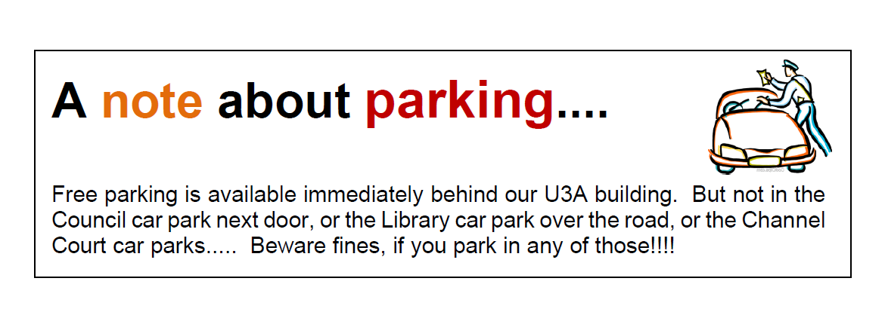

President: | Maureen Robinson |  | Programmer: |  | Helen Lindsay
Vice- Presidents: | Helen Lindsay  Heather Fiscalini |  | Newsletter: | Georgina Thiele
Secretary: | Walter Giardini |  | Woodbridge Representative: | Jean Lea
Treasurer: | Marja Harris |  | Social: | Karen McCrone & Co
Public Officer: | Karen McCrone |  | Email: | u3akingborough@gmail.com
Committee Members: | Sue Blackwood, Beate Oxley, Jeanetter Ritter, Russell Lawrence, Mary Ellen MacDonald |  | Website: | www.u3akingborough.org.au
Coffee & Chat

Every week – friends invited – no need to book

Saturdays10.30 Timeless Way

Channel Court, Kingston

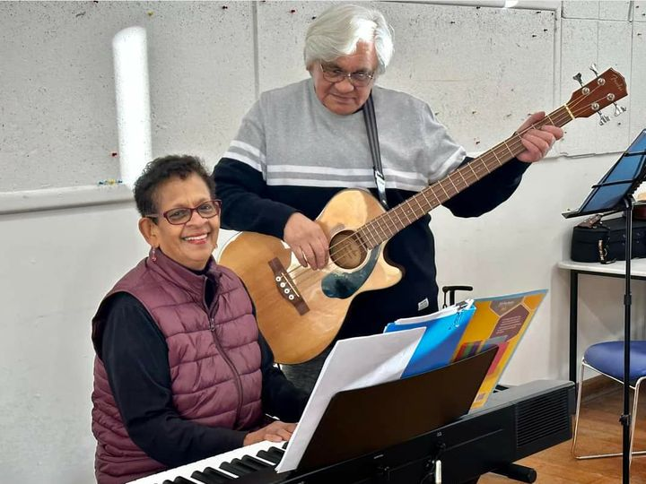
Come and join our
Sing-A-Long

Tuesday morning sing-a-long. 10am to 11am Block C. Nothing like some deep breathing and a good laugh. The words are on a screen, Shanthi plays her keyboard, George strums the guitar, and everyone else sings along.
Some we get right and some we don’t. The songs range from your Dad’s favourites to Creedence and Elvis.
Aimed for Not Too Serious Seniors who just want to exercise their vocal chords.

Kingston Library Exhibition

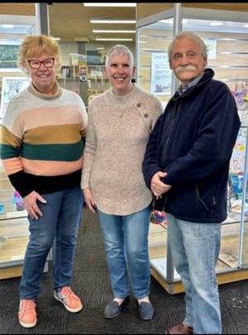
Our wonderful Committee members and helpers
were up bright and early on the first week in July,
setting up an excellent display of the wide range
of activities available at U3A Kingborough

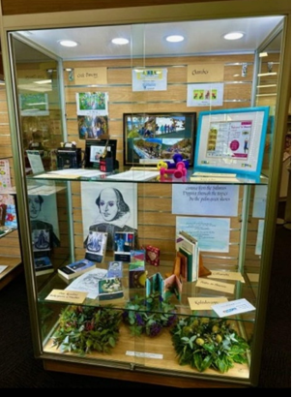
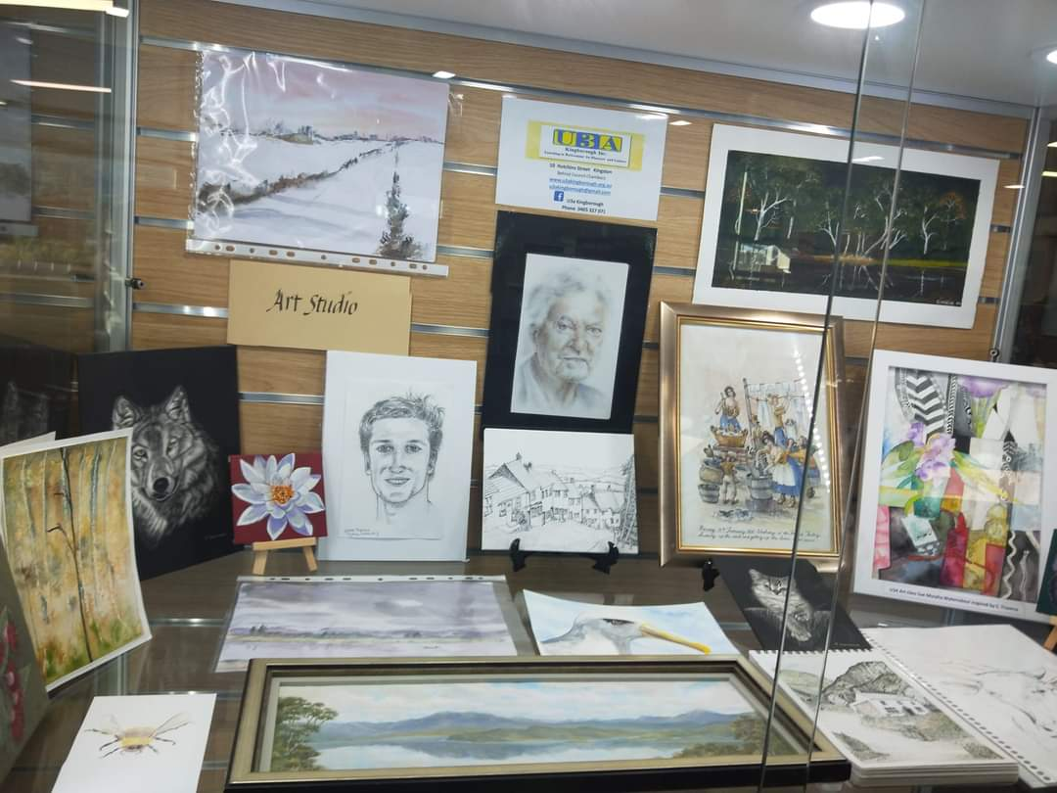

As you can see our art works, craft, flower
arranging, languages, creative writing, physical
exercise and more cerebral activities were all
beautifully presented.

U3A Kingborough Calendar
 |  |  |  |  |  |  |  | 2023
Public Holiday |  |  |  |  |  |  |  | Terms |  |  |  |  |  |  |  | Enrolment Day / Committee
AGM |  |  |  |  |  |  |  | Committee |  |  |  |  |  |  |  | Newsletter Deadline
January |  |  |  |  |  |  |  | Febuary |  |  |  |  |  |  |  | March - Term1
S | M | T | W | T | F | S |  | S | M | T | W | T | F | S |  | S | M | T | W | T | F | S
1 | 2 | 3 | 4 | 5 | 6 | 7 |  |  |  |  | 1 | 2 | 3 | 4 |  |  |  |  | 1 | 2 | 3 | 4
8 | 9 | 10 | 11 | 12 | 13 | 14 |  | 5 | 6 | 7 | 8 | 9 | 10 | 11 |  | 5 | 6 | 7 | 8 | 9 | 10 | 11
15 | 16 | 17 | 18 | 19 | 20 | 21 |  | 12 | 13 | 14 | 15 | 16 | 17 | 18 |  | 12 | 13 | 14 | 15 | 16 | 17 | 18
22 | 23 | 24 | 25 | 26 | 27 | 28 |  | 19 | 20 | 21 | 22 | 23 | 24 | 25 |  | 19 | 20 | 21 | 22 | 23 | 24 | 25
29 | 30 | 31 |  |  |  |  |  | 26 | 27 | 28 |  |  |  |  |  | 26 | 27 | 28 | 29 | 30 | 31
April – Term 1 |  |  |  |  |  |  |  | May – Term 1 |  |  |  |  |  |  |  | June – Term 2
S | M | T | W | T | F | S |  | S | M | T | W | T | F | S |  | S | M | T | W | T | F | S
 |  |  |  |  |  | 1 |  |  | 1 | 2 | 3 | 4 | 5 | 6 |  |  |  |  |  | 1 | 2 | 3
2 | 3 | 4 | 5 | 6 | 7 | 8 |  | 7 | 8 | 9 | 10 | 11 | 12 | 13 |  | 4 | 5 | 6 | 7 | 8 | 9 | 10
9 | 10 | 11 | 12 | 13 | 14 | 15 |  | 14 | 15 | 16 | 17 | 18 | 19 | 20 |  | 11 | 12 | 13 | 14 | 15 | 16 | 17
16 | 17 | 18 | 19 | 20 | 21 | 22 |  | 21 | 22 | 23 | 24 | 25 | 26 | 27 |  | 18 | 19 | 20 | 21 | 22 | 23 | 24
23 | 24 | 25 | 26 | 27 | 28 | 29 |  | 28 | 29 | 30 | 31 |  |  |  |  | 25 | 26 | 27 | 28 | 29 | 30
30
July Term 2 |  |  |  |  |  |  |  | August – Term2 |  |  |  |  |  |  |  | September – Term3
S | M | T | W | T | F | S |  | S | M | T | W | T | F | S |  | S | M | T | W | T | F | S
 |  |  |  |  |  | 1 |  |  |  | 1 | 2 | 3 | 4 | 5 |  |  |  |  |  |  | 1 | 2
2 | 3 | 4 | 5 | 6 | 7 | 8 |  | 6 | 7 | 8 | 9 | 10 | 11 | 12 |  | 3 | 4 | 5 | 6 | 7 | 8 | 9
9 | 10 | 11 | 12 | 13 | 14 | 15 |  | 13 | 14 | 15 | 16 | 17 | 18 | 19 |  | 10 | 11 | 12 | 13 | 14 | 15 | 16
16 | 17 | 18 | 19 | 20 | 21 | 22 |  | 20 | 21 | 22 | 23 | 24 | 25 | 26 |  | 17 | 18 | 19 | 20 | 21 | 22 | 23
23 | 24 | 25 | 26 | 27 | 28 | 29 |  | 27 | 28 | 29 | 30 | 31 |  |  |  | 24 | 25 | 26 | 27 | 28 | 29 | 30
30 | 31
October – Term3 |  |  |  |  |  |  |  | November – Term 3 |  |  |  |  |  |  |  | December
S | M | T | W | T | F | S |  | S | M | T | W | T | F | S |  | S | M | T | W | T | F | S
1 | 2 | 3 | 4 | 5 | 6 | 7 |  |  |  |  | 1 | 2 | 3 | 4 |  |  |  |  |  |  | 1 | 2
8 | 9 | 10 | 11 | 12 | 13 | 14 |  | 5 | 6 | 7 | 8 | 9 | 10 | 11 |  | 3 | 4 | 5 | 6 | 7 | 8 | 9
15 | 16 | 17 | 18 | 19 | 20 | 21 |  | 12 | 13 | 14 | 15 | 16 | 17 | 18 |  | 10 | 11 | 12 | 13 | 14 | 15 | 16
22 | 23 | 24 | 25 | 26 | 27 | 28 |  | 19 | 20 | 21 | 22 | 23 | 24 | 25 |  | 17 | 18 | 19 | 20 | 21 | 22 | 23
29 | 30 | 31 |  |  |  |  |  | 26 | 27 | 28 | 29 | 30 |  |  |  | 24 | 25 | 26 | 27 | 28 | 29 | 30
 |  |  |  |  |  |  |  |  |  |  |  |  |  |  |  | 31
*****Save the Date *****
End of Year Lunch
Friday 24th November

TERM 3 - AT A GLANCE 2023
Monday 25th Sept – Thursday 30th November

KINGSTON
MONDAY | 9.30 - 10.30 | Tai Chi | Maureen Robinson | A1
 | 9.30 - 11.45 | Art Studio | Self managed | A2
 | 9.30 - 11.30 | Mah Jong | Self managed | A3
 | 10.30 – 11.30 | Welsh Beginners | Bronwen Parr | A4
 | 10.45 – 11.45 | French Conversation | Mary Ellen MacDonald | A1
 | 11.45 - 1.00 | Book Chat | Libbie Davies | A3
 | 12.00 - 1.00 | Meditation | Self managed | A1
 | 12.15 – 1.15 | French Basics | Ruth Lawry | A2
 | 1.30 - 2.30 | Simple Tai Chi & Qi Gong | Carol Bessell | Block D
 | 1.30 - 2.30 | Kaleidoscope | Various | A1
 | 1.30 – 2.30 | Life and Death in Ancient Greece | Anthony Boden | A3
 | 1.30 - 3.00 | Welsh Advanced | Bronwen Parr | A4
 | 1.30 – 3.00 | Cryptic Crosswords | Julie Gardam | Offsite
TUESDAY | 9.00 | Bushwalking | Ron & Peter | Field
 | 10.00 -11.00 | Art Self Study Group | Walter Giardini | A1
 | 10.00 -11.00 | Have your Say | Keith Anderson | A2
 | 10.00 -11.00 | Balance your Bones | Sue Blackwood | A3
 | 10.00 – 11.00 | Sing-a-long | Helen and Shanthi | Block C
 | 11.30 – 12.30 | Bringing Life to Family History | David Boon | A1
 | 11.30 -12.30 | Playreading: Shakespeare’s Comedies | Tony Nicholls | A2
 | 1.00 – 3.00 | Creative Writing | Annette Starik | A1
 | 1.00 - 3.00 | Stitch, knit and chat | Jaylene Seabrook | A2
 | 1,00 - 2.00 | Chairobics | Jeanette Ritter | A3
 | 1.45 - 3.15 | Circle Dancing | Kate Shaw | KB Hall
WEDNESDAY | 10.00 | Ramblers 1 | Carol, Wayne & Donna | Field
 | 10.00 | Ramblers 2 | Julie Gardam | Field
 | 10.30 - 12.30 | Strollers | Bob Muirhead | Field
THURSDAY | 9.30 - 11.00 | Advanced Cryptic Crosswords | Cathie Lewis | A4
 | 9.30 - 10.30 | Balance Your Bones | Maureen Robinson | A3
 | 10.00 -11.15 | Flower Arranging | Helen Lindsay | Block C
 | 10.00 – 11.00 | Famous Australians – Fact vs Rumour | Maureen Robinson | A1
 | 10.00 -11.15 | Latin, Continuing from 2021 | Margaret Jacobs | A2
 | 11.00-12.00 | Fit For Life | Jeanette Ritter | A3
 | 11.30-12.30 | Philosophy, Spirituality, Faith, Belief | Pam & Karen | A1
 | 11.30-12.30 | Calligraphy | Christine Farmer | A2
 | 11.30-12.30 | Simple Tai Chi and Qi Gong | Carol Bessell | Block D
 | 1.00 – 2.00 | South Asia – from Philippines to Pakistan | Peter Jones | A1
 | 1.00 –3.00 | Bridge Club | Self managed | A3
 | 1.30 - 2.30 | Poetry for Pleasure | Self managed | A2

WOODBRIDGE
MONDAY | 1.30 - 3.30 | Words, Words, Words! | Self managed | Westwinds
FRIDAY | 10.30 - 11.30 | Meditation | Margaret Jacobs | Woodbridge Church

KINGSTON COURSES Term 3 2023

Monday 9.30 - 10.30 A1
Tai Chi Maureen Robinson
Slow, gentle exercise, breathing and stretching to lower blood pressure, reduce stress and maintain flexibility. Wear loose, comfortable clothes.

Monday 9.30 - 11.45 A2
Art Studio Self managed
This class is a continuation of one that has been meeting regularly. The studio offers a place for relaxation through Art. Be part of group creativity. Come along with paint and pencils.

Monday 9.30 - 11.30 A3
Mah Jong Self managed
Here is your chance to play or learn how to play the ancient Chinese game of Mah Jong. It is now popular around the world. Any newcomers are very welcome. If you have a Mah Jong set do bring it along. If you don't have your own set, there are some sets available for class use.

Monday 10.30 to 11.30 A4
Welsh Beginners Bronwen Parr
This is an opportunity to learn one of the oldest languages, spoken in Wales for about 1600 years. Our emphasis is on everyday situations, for example, greetings, shopping, family, weather, at the café, likes and dislikes, sport and travel. We also cover some history of Wales. This will give your brain a good workout when you learn pronunciation, sentence pattern and vocabulary. It’s fun too.

Monday 10.45 to 11.45 A1
French Conversation Dr. Mary Ellen MacDonald
Mary Ellen has taught French and German on three continents, speaks French and German fluently, and is familiar with 5 other languages. She studied in Canada, Europe and Australia in language music, history and theology. She loves the class and is looking forward to continuing.

Monday 11.45 - 1.00 A3
Book Chat Libbie Davies
Book Chat provides a friendly space for book lovers to share their views and chat about their latest book. We discover new authors to add to our reading list and gain different perspectives on a variety of topics. The group also selects specific genres or themes to focus on throughout the term. Do join us.

Monday 12.00 – 1.00 A1
Meditation Self managed
This class practises various meditation methods.

Monday 12.15 – 1.15 A2
French Basics Ruth Lawry
Come and learn the basics of French to use for travel Conversation

Monday 1.30 to 2.30 Block D
Simple Tai Chi and Qi Gong Carol Bessell
Experience the differences and similarities of both these gentle styles of low impact exercise. Practise the short routines of Qi Gong and the longer flowing forms of Tai Chi, to discover why and how they improve flexibility, strength and balance.

Monday 1.30 - 2.30 A1
Kaleidoscope Various
An exciting and different subject each week, with topics from the practical to the challenging, from health to holidays. An interesting hour with speakers passionate about their subject.

Monday 1.30 – 2.30 A3
Life and Death in Ancient Greece Anthony Boden
The Greeks! What were they like? Where did they come from? In what ways did they differ from us? In this completely new series, we present a portrait of the Greeks as a people. We’ll look at their laws, their beliefs, and the ways in which they thought, worked and played. But this is not all. In the process, we will encounter some of those things which you never really hear about: plagues, colonies and unusual approaches to government. So, join us in this voyage of discovery. You may find that these people have more to offer than vases, temples and philosophical speculation.

Monday 1.30 to 3.00 A4
Welsh Advanced Facilitated by Bronwen Parr
If you have covered the content of the beginners Welsh class, or have learnt Welsh from SSIW, Duolingo, Teach Yourself texts etc, come and join the Advanced Group
We enjoy Welsh music together, translating current articles, conversing with each other, and we are currently working from the textbook “UWCH 1 Dysgu Cymraeg, Gogledd Cymru”
This is in digital form as well. We hope to see you – Hwyl am y Trol

Monday 1.30 – 3.00 Off site
Cryptic Crosswords Julie Gardam
The group will continue to work collaboratively to unravel the secrets of success in this masochistic recreation. Anyone interested in the fiendish ‘cryptic world’ is welcome. Bring a pen/pencil and prepare your brain for scrambling.

* * * * * * * * * * * * * * * *
Tuesday 9.00 Field
Bushwalking Ron Krois & Peter Rowell
The walks, of 7 to 15kms, will be on established tracks and trails about the uplands and coasts around Hobart and occasionally further afield. Duration will be 3 to 5 hours. Participants need a reasonable fitness level. Bring your lunch, water and a first aid kit. The meeting place for all walks is the Community Centre car park, Redwood Road. Be there in time to leave at 9:00 am where carpooling will require the use of masks during travel.
* Members new to the group please phone either Peter 0409 942 586 or Ron 0408 997 597 prior to the start of term.

Tuesday 10.00 - 11.00 A1
Art Study Group Walter Giardini
We will endeavour to make a space in which to talk and learn about art, and develop an understanding of the function and meaning of art in the world through the lens of art works themselves. Mostly “Talks” format but looking to be driven by and with lots of input from class participants.

Tuesday 10.00 – 11.00 A2
Have Your Say Keith Anderson
Members of this lively group discuss a wide range of topics, ranging from politics, world events, science, through to humanities and religion. Our rules maintain respect for other’s opinions, although challenging discussion is encouraged. Each participant has an opportunity to speak without interruption, and may express any discomfort about others’ opinions. Confidentiality within the group assures members that their opinion stays in the room, thus allowing them to speak freely on the issues involved.

Tuesday 10.00 - 11.00 A3
Balance your Bones Sue Blackwood
This exercise class is for the pre-lycra generation. You will need comfortable, loose clothing. Bring a water bottle. The class will be based around an exercise DVD produced by an experienced and qualified instructor from the Wollongong U3A.

Tuesday 10.00 – 11.00 Block C
Sing-a-Long Helen and Shanthi
Do you love singing? In the shower, in the car, singing along to the radio? Come along and have a healthy sing and laugh. No pressure, or need to read music. We will provide the piano and words. If you want to, bring an instrument; kazoo, yuke, castanets. Please feel free to join in.

Tuesday 11.30 – 12.30 A1
Bringing Life to Family History David Boon
These sessions will explore how to move beyond the basic details in birth, marriage and death records to learn more about the lives of our ancestors. Learn how records relating to schools, hospitals, cemeteries, courts, police, welfare and land can reveal details of individual lives and how local histories and newspapers can provide further context. Explore how DNA testing can reveal hidden stories, confirm family folklore and reveal deep ancestry. Each session will draw on examples from my own research and provide details of how participants can access resources to undertake their own research.

Tuesday 11.30 – 12.30 A2
Playreading Tony Nicholls
Shakespeare Comedies: we will read an early one and then a mature one.

Tuesday 1.00 – 3.00 A1
Creative Writing Facilitator Annette Starik
This course is for anyone who loves to write! Whether you are an experienced writer or a beginner, we’d love you to join us! You’ll find the group fun, reassuring and helpful.
The emphasis is on imagination and creativity and to that end, group members are encouraged to participate in a 10 minute informal writing exercise and to complete optional homework for reading out, at the following class.

Tuesday 1.00 - 3.00 A2
Stitch, knit and chat Jaylene Seabrook
This sociable group will share knowledge of skills and techniques, ideas and fabrics, wools and cottons. Bring along a portable sewing machine if needed. Novice and experienced patchworkers and embroiderers, tapestry and cross-stitchers, knitters etc. welcome.

Tuesday 1.00 - 2.00 A3
Chairobics Jeanetter Ritter
An easy way for seniors to exercise. Increase your flexibility, increase your coordination and circulation. Also improve your posture, reduce risks of falls. Great for Seniors!

Tuesday 1.45 – 3.15 Kingston Beach Hall
Circle Dancing Kate Shaw
Circle Dancing continues with a programme of traditional and contemporary dances from around the world. Newcomers are welcome and all dances will be taught. Bring comfortable footwear.

* * * * * * * * * * * * * * * *

Wednesday 10.00 Field
Ramblers 1 Carol Timbrell, Wayne Seabrook & Donna Hartley
Easy 1.5 to 2 hour walks, enjoying nature and fresh air on local and rural tracks and trails for an invigorating, healthy social activity, always ending with a welcome cuppa or lunch in a nearby cafe. The group meets in the Community Centre car park, Redwood Road at 9:45 am ready to leave by 10 am. Car-pooling is organised on the morning of the walk where masks will be necessary during the trip. NB This group is for continuing members who enrolled in 2018 only.

Wednesday 10.00 Field
Ramblers 2 Julie Gardam
This group meets at the Senior Cits carpark depart at 10.00am. Walks are 1.5 to 2.5 hours on made tracks and usually followed by an optional social meal in a nearby eatery. A walking group with an eating problem or vice versa.

Wednesday 10.30 - 12.30 Field
Strollers Bob Muirhead
The walks are for about an hour on urban footpaths, wide “made” tracks or single-file bush tracks. Occasionally they can be rough underfoot and a little hilly. In the greater Kingston area, hills are hard to avoid, so we enjoy them slowly. We meet at the start of the walks at 10.30 am

* * * * * * * * * * * * * * * *

Thursday 9.30 - 11.00 A4
Advanced Cryptics Cathy Lewis
Long-term cryptic crossword fiend, Cathie Lewis, will lead the group in solving cryptic clues in a collaborative group. She is happy to give crosswords for ‘homework’ and for the group to work through the solutions the following week. Bring a pen/pencil and paper.

Thursday 9.30 – 10.30 A3
Balance your Bones Maureen Robinson
This exercise class is for the pre-lycra generation. You will need comfortable, loose clothing. Bring a water bottle. The class will be based around an exercise DVD produced by an experienced and qualified instructor from the Wollongong U3A.

Thursday 10.00 to 11.15 Block C
Flower Arranging Fresh and Dried Helen Lindsay
Come and share the delight in displaying your flowers in a variety of decorative arrangements suitable for many occasions. Learn the importance of size, colour, and form. Explore the beauty of using bark, seed pods, succulents and any botanical material to enhance your arrangements.

Thursday 10.00 – 11.00 A1
Famous Australians – Fact vs Rumour Maureen Robinson
Personal details, scandals, stories and photos of people who’ve put Australia on the map, from Errol Flynn to Ash Barty.

Thursday 10.00 - 11.15 A2
Latin, Continuing Margaret Jacobs
This class is a continuation, based on the study done in 2021. If you have studied Latin previously and wanted to join, please first contact Margaret on seaglint7@gmail.com

Thursday 11.00 to 12.00 A3
Fit For Life Jeanette Ritter
Total body workout, includes balance, weights and resistance training. Please wear comfortable shoes and clothing.

Thursday 11.30 to 12.30 A1
Philosophy, Spirituality, Faith & Belief Pam Poulsen & Karen McKrone
This course will be a continuation of the course, Many Religious Beliefs. Spiritual Faiths, bringing back some of the extraordinarily interesting speakers from last year and asking them to be available, if possible, for more than one session, as requested by members who attended last year. These presentations will have a multi faith approach. The presenters will choose their topic. We are still interested in some of the key precepts or spiritual beliefs, and the way in which the institution sees itself as serving the community.
Last year this course was a very full class. Members should expect to attend all sessions and take the opportunity to discuss and ask questions. If interested book early.

Thursday 11.30 to 12.30 A2
Calligraphy Christine Farmer
We will work with a broad pen and ink in Italic, the script which was developed for speed and simplicity during the Renaissance, and is still the most popular and versatile script in C21. We will also work on small projects suitable for beginners and continuers. Cost of basic materials will be about $30.

Thursday 11.30 - 12.30 Block D
Simple Tai Chi and Qi Gong Carol Bessell
Experience the differences and similarities of both these gentle styles of low impact exercise. Practise the short routines of Qi Gong and the longer flowing forms of Tai Chi, to discover why and how they improve flexibility, strength and balance.

Thursday 1.00 – 2.00 A1
South Asia – form the Philippines to Pakistan Peter Jones
The government now refers to the “Indo-Pacific” so this course covers who our neighbours are in South East and South Asia.

Thursday 1.00 - 3.00 A3
Bridge Club Self Managed
Bridge players can come along and play a game and get assistance from each other. Newcomers with Bridge-playing experience are welcome.

Thursday 1.30 - 2.30 A2
Poetry for Pleasure Self Managed
Do you enjoy reading and listening to poetry? Then this might be for you. Lovers of poetry come together each week to read, hear and share their favourite poems in an informal and relaxed atmosphere. Perhaps you might have an original piece that you might like to share with the group? Please bring along one or three shortish poems. They may be serious, funny or whimsical but do come and enjoy!

WOODBRIDGE COURSES

Monday 1.30 - 3.30 Westwinds
WORDS, WORDS, WORDS! Self Managed
Only 26 letters and in their infinite permutations produce the thousands of words with which we can communicate either by reading, writing, or speaking. Join our discussion group to talk about a book you are reading, a poem you love, an interesting article or a cartoon that particularly appeals. Or maybe you have written something you would like to share. Any genre from the sublime to the ridiculous. Explore words that have changed meaning over time, words that have disappeared, new words that puzzle. All fascinating stuff and interesting to explore and discuss.

Friday 10.30 - 11.30 Anglican Church, Woodbridge
Meditation Margaret Jacobs
A quiet mind brings a sense of peace and encourages inner strength. Research shows that meditation also has many physiological as well as mental benefits. When the normally incessant mental dialogue ceases for a while, then anxiety falls away and this facilitates healing on many levels. Practising meditation in a group creates an atmosphere that enhances the process, making it easier to learn. In these sessions you will be guided through the processes that lead to a quiet mind and a feeling of peace.
For more information on this course you can contact Margaret at seaglint7@gmail.com

As members of Kingborough U3A we get four days a week of varied and interesting activities over three terms for only $50.

Amazing !!!!!



ENROLMENTS

*Online enrolment is now available

You can enrol in as many courses as you like if you think you can attend most or all weeks of the course. Please use a separate enrolment form for each member.

Doubling up can cause confusion.

Assume your enrolment has been accepted UNLESS WE NOTIFY YOU OTHERWISE.
Please ensure you enrol each term, not just turn up. There are class limits in place in some activities and you may not be able to join.

Please keep a record of the courses you have enrolled in, perhaps using the ‘At a Glance’ from the newsletter!

Items of Special Note:

Visitors are welcome to attend U3A courses if space is available. Please check with the course Rep. at the classroom door.

Keep your eye on the U3A Notice Board for upcoming events etc.

Please look out for new members to U3A and make them welcome. A friendly greeting can make a difference.

In the case of a collapse, or seemingly serious medical condition of any member – as part of our “duty of care”, a committee member (or other) is to call an ambulance on 000 without consultation. The ‘patient’ and ambulance personnel can take it from there.

A REMINDER: Drivers, please don't forget that the car entering the laneway into our parking area has right of way. If you are trying to exit at the same time, you need to back up as the vehicle in Church Street is in a very dangerous position and has nowhere to go.

NEW MEMBERS

When you enrol be sure to collect an “Information for New Members” pamphlet from the document holder in the hallway.

Name badges should be on the wall in the hallway, early in the term. If yours is not there, please leave your name on the paper next to it. We do periodic print runs.

Please consider downloading your newsletter from our U3A website. A considerable amount of time has to be spent by volunteers folding and preparing your newsletter for posting, and we would like to reduce this workload where possible. We would also like to keep our postage to a minimum, especially with the increase in postal prices.

Membership and Enrolment forms are available in A Block building, 8 Hutchins Street, Kingston.
U3A KINGBOROUGH INC.

MEMBERSHIP SUBSCRIPTION
New Membership or Membership Renewal is now available online
$50 Terms 1, 2 & 3
$35 Terms 2 & 3
$20 Term 3

Your subscription entitles you to Membership for the calendar year 2023.
New members will be issued with a name badge early in the term.
NOTE: If you do not enrol in any courses this term, the subscription is not refundable as it also covers the rest of the year.
Payment Options
There are several ways to join and pay:
  - Bring your completed form and payment and put it in the U3A box on the wall, A Block Building, 8 Hutchins Street, Kingston.
  - Post your form with cheque to U3A Kingborough, PO Box 479 Kingston TA 7051.
  - Pay your subscription by Direct Debit quoting your name and Email your completed form to u3akingborough@gmail.com

The form can also be downloaded from the Join U3A page on our website at
www.u3akingborough.org.au

A/c Name: U3A Kingborough
Bank: Westpac BSB: 037 015
A/c No: 12 98 26
Please put your name in the “description” box so that your payment can be identified.
Pease do not pay at the bank because your name does not appear on our bank statement .
. . . . . . . . . . . . . . . . . . . . . . . . . .
U3A Kingborough

Annual membership payment: cheque, credit card, cash, direct debit for $_________
Please print name & address on the back of cheque or money order.

First Name: Surname: Title:

I am a NEW MEMBER I am a returning member

Preferred name for badge: Phone No.

Address: Postcode:

I wish to download the U3A Kingborough newsletters (PDF format) from our website. (An email will alert you when it is ready.) YES / NO

Email Address – Please PRINT CLEARLY AND ACCURATELY as the address needs to be legible and correct.

__________________________________________________@__________________________________________
TERM 3 - 2023 Enrolment Form
There are four ways to enrol:
- Please email the completed form to u3akingborough@gmail.com It can also be downloaded from the Enrolment page on our U3A website at www.u3akingborough.org.au
- Post the completed form to U3A Kingborough, PO Box 479 Kingston TAS 7051
- Bring the completed form to Hutchins St building and put it in the U3A box on the wall.
- You can now enrol online through our website www.u3akingborough.org.au
First Name: ...………...................................Surname:

Email:......................................................................................... Phone Nº:....................................
I declare that I have been fully vaccinated for COVID-19
Signed:…………….………………..
KINGSTON X to enrol
MONDAY | 9.30 - 10.30 | Tai Chi | A1
 | 9.30 - 11.45 | Art Studio | A2
 | 9.30 - 11.30 | Mah Jong | A3
 | 10.30 – 11.30 | Welsh Beginners | A4
 | 10.45 – 11.45 | French Conversation | A1
 | 11.45 - 1.00 | Book Chat | A3
 | 12.00 - 1.00 | Meditation | A1
 | 12.15 – 1.15 | French Basics | A2
 | 1.30 - 2.30 | Simple Tai Chi & Qi Gong | Block D
 | 1.30 - 2.30 | Kaleidoscope | A1
 | 1.30 – 2.30 | Life and Death in Ancient Greece | A3
 | 1.30 - 3.00 | Welsh Advanced | A4
 | 1.30 – 3.00 | Cryptic Crosswords | Offsite
TUESDAY | 9.00 | Bushwalking | Field
 | 10.00 -11.00 | Art Self Study Group | A1
 | 10.00 -11.00 | Have your Say | A2
 | 10.00 -11.00 | Balance your Bones | A3
 | 10.00 – 11.00 | Sing-a-long | Block C
 | 11.30 – 12.30 | Bringing Life to Family History | A1
 | 11.30 -12.30 | Playreading: Shakespeare’s Comedies | A2
 | 1.00 – 3.00 | Creative Writing | A1
 | 1.00 - 3.00 | Stitch, knit and chat | A2
 | 1,00 - 2.00 | Chairobics | A3
 | 1.45 - 3.15 | Circle Dancing | KB Hall
WEDNESDAY | 10.00 | Ramblers 1 | Field
 | 10.00 | Ramblers 2 | Field
 | 10.30 - 12.30 | Strollers | Field
THURSDAY | 9.30 - 11.00 | Advanced Cryptic Crosswords | A4
 | 9.30 - 10.30 | Balance Your Bones | A3
 | 10.00 -11.15 | Flower Arranging | Block C
 | 10.00 – 11.00 | Famous Australians – Fact vs Rumour | A1
 | 10.00 -11.15 | Latin, Continuing from 2021 | A2
 | 11.00-12.00 | Fit For Life | A3
 | 11.30-12.30 | Philosophy, Spirituality, Faith, Belief | A1
 | 11.30-12.30 | Calligraphy | A2
 | 11.30-12.30 | Simple Tai Chi and Qi Gong | Block D
 | 1.00 – 2.00 | South Asia – from Philippines to Pakistan | A1
 | 1.00 –3.00 | Bridge Club | A3
 | 1.30 - 2.30 | Poetry for Pleasure | A2

WOODBRIDGE
MONDAY | 1.30 - 3.30 | Words, Words, Words! | Westwinds
FRIDAY | 10.30 - 11.30 | Meditation | Woodbridge Church

